PRESS RELEASE
January 18, 2021

Stepper Drives Deliver Servo Performance

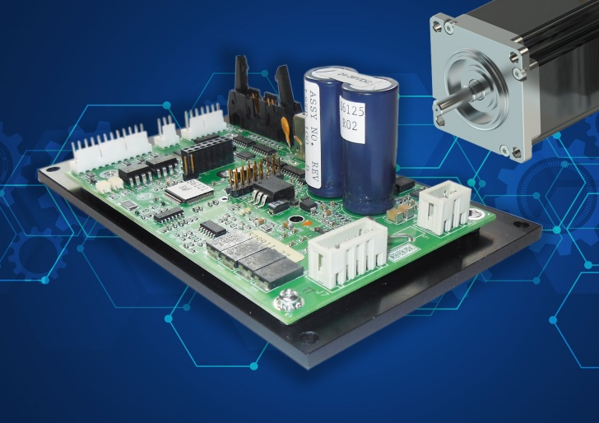
Designed specifically for OEM machinery control applications, the Luminary Series Stepper Drives from Industrial Indexing Systems packs offers servo-level motion performance, and also a full complement of interface options.

Steppers Offer Servo Performance
By using integral encoder feedback, no loss of shaft position under peak torque conditions and quiet operation are true benefits when applied in many environments.

Full Control for Less Cost
This stepper drive and motor combination, when networked with the LMC-400 controller, uses the standard Emerald Motion Language and the EDE software tool kit to provide electronic cam motion, electronic gearing and programmable limit switch outputs for synchronized and coordinated motion profiles.

Versatile Drive Interface
Designed with the OEM in mind, the Luminary Series Stepper drive provides a full complement of interface options. Analog velocity and torque control, digital encoder feedback, and digital input and output control points provide flexible design options needed by the OEM.

Press Contact
Tina Ebmeyer
Industrial Indexing Systems (IIS)
(585) 924-9181
tinae@iis-servo.com
www.iis-servo.com

